Jenkins Enterprises Low-Level Concerns Policy

Low level concerns
The safety and wellbeing of students in our care is dependent on the vigilance of all our staff and their prompt communication to the DSL Maryna Jenkins of any concerns, no matter how small, about any conduct by an adult which causes you to doubt that adult’s suitability to work with or have access to children. All references in this section to “adult” should be interpreted as meaning any adult, including staff, volunteers, homestays, visitors to homestay families, school staff and other adults who work with our organisation, unless otherwise stated. Jenkins Enterprises is conscious of its duty of care to students and will always act, including if alerted to the possibility of abuse arising from situations or persons outside our care. The notification and prompt handling of all concerns about adults is fundamental to safeguarding students. It helps to identify and prevent abuse and to protect adults against misunderstandings or misinterpretations. It also encourages openness, trust and transparency and it clarifies expected behaviours.
Those raising concerns or reporting allegations in good faith will always be supported, and adults in respect of whom concerns or allegations have been raised will not suffer any detriment unless the concern or allegation is found to be substantiated. We are a ‘telling’ organisation. If you are concerned about the behaviour or actions of any adult, speak to the DSL Maryna Jenkins.

Code of Conduct
All staff and Homestays must behave responsibly and professionally in all dealings with students and specifically with those for whom they have a duty of care. All staff and Homestays must follow the procedures set out in our ‘Staff and Homestay Code of Conduct’. Staff and Homestays should always avoid behaviour which might be misinterpreted by others. As a result of their knowledge, position and/or the authority invested in their role, all adults working with children and young people are in positions of trust in relation to the young people in their care. A relationship between a member of staff or Homestay and a student cannot be a relationship between equals. There is potential for exploitation and harm of vulnerable young people and all members of staff and Homestays have a responsibility to ensure that an unequal balance of power is not used for personal advantage or gratification.
Staff and Homestays should note that it is an offence for a person aged 18 or over and in a position of trust to touch a child in a sexual way or have a sexual relationship with a child, even if the relationship is consensual. A position of trust could arise even if the member of staff does not directly work with the student.

Our low-level concern policy
The overarching aim of the Low-Level Concern Policy is to facilitate a culture in which the clear values and expected behaviours which are set out in our Code of Conduct are lived, constantly monitored, and reinforced by all staff and Homestays. In particular, the intention of this policy is to:
- maintain a culture of openness, trust and transparency in which staff and Homestays are confident and clear about expected behaviours of themselves and their colleagues, the delineation of boundaries and reporting lines;
- ensure staff and Homestays feel empowered to raise any low-level concern, whether about their own or a colleague’s behaviour, where that behaviour might be construed as falling short of the standards set out in our Code of Conduct; and Safeguarding and Child Protection Policy and Procedure;
- provide for responsive, sensitive and proportionate handling of such concerns when they are raised maintaining on the one hand confidence that concerns when raised will be handled promptly and effectively whilst, on the other hand, protecting staff from false allegations or misunderstandings.

What is a low-level concern?
A low-level concern for this purpose is any concern, no matter how small and even if no more than a ‘nagging doubt’, that an adult may have acted in a manner inconsistent with the Guardianship Organisation’s Code of Conduct or simply
- even if not linked to a particular act or omission
- a sense of unease as to the adult’s behaviour particularly towards or around students.

Low-Level Concerns about self (self-reporting)
From time to time an individual may find him/herself in a situation which might appear compromising to others or which could be misconstrued. Equally, an individual may for whatever reason have behaved in a manner which on reflection he/she considers falls below the standard set out in the Code of Conduct. Self-reporting in these circumstances is encouraged as it demonstrates both awareness of the expected behavioural standards and self-awareness as to the individual’s own actions or how they could be perceived. As such, the guardianship organisation sees self-reporting of low-level concerns as an important means of maintaining a culture where everyone aspires to the highest standards of conduct and behaviour.

Low-Level Concerns about an adult
From time to time an individual may notice behaviour or actions in others which leave them concerned. These are behaviour or actions which fall short of a formal allegation of abuse. These tend to be behaviours which indicate that our Code of Conduct has not been met. Any such concerns can be dealt with as a Low-Level Concern.

What should I do if I have one?
Where a low-level concern exists it should be reported to the DSL Maryna Jenkins as soon as reasonably possible and, in any event, within 24 hours of becoming aware of it (where the concern relates to a particular incident).

How will my low-level concern be handled?
the DSL Maryna Jenkins will, in the first instance, satisfy herself that it is a low-level concern and should not be reclassified as an allegation and dealt with under the appropriate procedure (outlined later in this document). The circumstances in which a low-level concern might be reclassified as an allegation are where:
- the threshold is met for an allegation
- there is a pattern of low-level concerns which collectively amount to an allegation or
- there is other information which when taken into account leads to an allegation.
Where the DSL Maryna Jenkins is in any doubt whatsoever, advice will be sought from the LADO, if necessary on a no-names basis. Having established that the concern is low-level, the DSL as appropriate will discuss it with the individual who has raised it and will take any other steps to investigate it as necessary. Most low-level concerns by their very nature are likely to be minor and will be dealt with by means of management guidance, training etc.

What records will be kept?
Where a low-level concern has been communicated, a confidential record will be kept in writing including details of the concern, the context in which the concern arose, how the concern was followed up and resolved, and a note of any action taken and decisions reached. This record will be kept in the employee’s confidential personnel file and a copy will be provided to the person concerned. This is necessary to enable any patterns to be identified. However, no mention of this will be made in job references unless either:
a) the concern (or group of concerns) has been reclassified as an allegation as above; or Safeguarding and Child Protection Policy and Procedure
b) the concern (or group of concerns) is sufficiently serious to result in formal action under the guardianship organisation's grievance, capability or disciplinary procedure.

Contact Details

Role | Name | Telephone Number | Email
DSL | Maryna Jenkins | +44 (0) 754 25 36 256 | infoukschools@gmail.com

Review
We are committed to reviewing our policy and good practice annually.
This policy was last reviewed on: 10.02.2023………………………………………………………(date)
Signed: 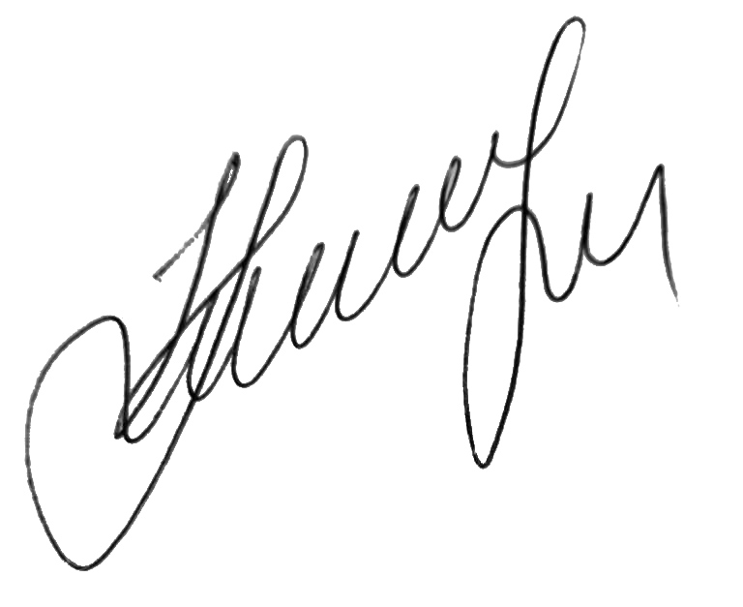…………………………………………………………………………
by the DSL Maryna Jenkins
Date: 10.02.2023…………………………………………………………

