Emergency Plan

Statement
The safety of our students is our main priority. Jenkins Enterprises acknowledges that there may be situations out of their control that require planning for. This plan outlines what Jenkins Enterprises will do in the event of an emergency.
(Please note that the scenarios are not exhaustive.)

Emergency Procedure

Dealing with an emergency
It is important that staff who receive an emergency call keep calm and remember to note all of the information provided. You may need to provide reassurance and support to the informant as they may be upset, suffering from shock or may panic.
- Ascertain out what has happened, gathering as much information as you can;
- Discuss with the informant what action needs to be taken and by whom;
- Keep a written record of the information and of any actions taken. (A template for recording incidents is included at end of this plan);
- The Director Maryna Jenkins should be informed immediately about the situation.
Specific scenarios
Please note that specific scenarios may require a bespoke plan that will include further details on how we will handle the issue. Where this is the case Jenkins Enterprises will circulate the plan with all relevant parties.

- Cancelled Flights
When a student’s flight is cancelled in the UK Jenkins Enterprises will arrange for suitable care. If necessary students will be accommodated in an emergency homestay until it is possible to travel. Where a student is waiting at an airport without a member of our staff, students are required to contact Jenkins Enterprises as soon as they are aware that their flights have been cancelled. Parents will be kept fully informed of the situation. Jenkins Enterprises will liaise with the airline and parents to re-arrange the flights.

- Pandemic/ Contagious Outbreak
Pandemics can cause major disruption to travel and schooling. It is important in such events to take advice from the government, Public Health England and the World Health Organisation. AEGIS provides guidance for members to follow. This is regularly updated as a situation develops. Usually, in a pandemic it is important to restrict movement so as not to spread the disease further. That means boarding school students would usually remain at school. In the event of a pandemic Jenkins Enterprises may not be able to offer homestay accommodation as this could place students, homestay families and the wider community at risk. Jenkins Enterprises will work with parents and schools to find suitable quarantine accommodation for students where required. Jenkins Enterprises will work with schools to meet students’ needs during a pandemic. This could be by helping to support students to learn remotely as directed by the school. Jenkins Enterprises will work with parents to find flights to home countries where required.

- Serious injury or death of a student
Serious injury or death of a student is distressing for all concerned. Jenkins Enterprises will:
- Liaise with medical staff and police
- Keep parents informed
- Help parents arrange flights
- Handle any media enquiries
- Liaise with schools and any other external agencies (such as LSP) where required
- If required, assist parents with rehabilitation and flights home
- If required, assist parents with funeral arrangements
- Terrorist incident
Schools will have their own lockdown procedures to ensure the safety of students in the event of a terror attack. In the event of a terror attack taking place in the UK when a student is staying at a homestay, Jenkins Enterprises will follow the guidance provided by the UK government and the police. Unless instructed otherwise, students will be asked to remain in the homestay and not to go out unaccompanied by their homestay. In such a situation Jenkins Enterprises will assess the risks and act accordingly.

Fire
In the event of a fire at a homestay, after dealing with the emergency by calling the fire brigade, the homestay is expected to inform Jenkins Enterprises . Students will be moved to a different homestay until the accommodation is refurbished. Jenkins Enterprises will visit the homestay to check the suitability of accommodation before any students return.

- School closures
There are many reasons why a school may close. These could be temporary, such as due to weather or a staff shortage or permanent, for example due to bankruptcy. Unless closure is due to a contagious disease (see pandemic guidance above), Jenkins Enterprises will provide accommodation for students with their homestays*.

Requests from schools to remove a student
Jenkins Enterprises has a plan in place for any student who cannot be accommodated by the school due to illness, disciplinary action or any other cause.
- Jenkins Enterprises will liaise with the student parents and school.
- Emergency homestay accommodation* will be arranged for the student, unless the student has a contagious disease (see pandemic guidance above).
- Jenkins Enterprises will liaise with the school to arrange the safe return of the student as soon a s possible.
Emergency Homestay Accommodation*
Please note that emergency homestay placements may not necessarily be with the students’ usual homestay, but will be with one of our vetted homestays who provide high levels of care. These homestays may be a greater distance from the school. Wherever possible we will place students with their usual homestay.
Jenkins Enterprises with partners Host International will provide emergency accommodation.
Emergency Contact Details- Guardian Organisation staff
Organisation | Contact details
Jenkins Enterprises | Name: Maryna Jenkins  Phone: +44 (0) 754 25 36 256  e-mail: infoukschools@gmail.com

Contact Details- other organisations
Organisation | Contact details
Police | Tel: 999 (24 hour)  Tel: 101 (24 hour, non-emergency number)
Fire & Rescue service | Tel: 999 (24 hour)
Ambulance service | Tel: 999 (24 hour)
National Health Service | Tel: 111 (24 hour)
AEGIS | Tel: 01453 821 293
Foreign & Commonwealth Office | Tel: 0207 008 1500 (24 hour, consular assistance)
Environment Agency | Tel: 0345 988 1188 (24 hour Floodline)
Met Office | Tel: 0370 900 0100 (24 hour, weather desk)
Health and Safety Executive | Incident Contact Centre: 0345 300 9923 (Monday to Friday 8.30am until 5pm)  Out of hours duty officer (24 hour): 0151 922 9235  www.hse.gov.uk
Public Health England | www.gov.uk/government/organisations/public-health-england  Main Switchboard: 020 7654 8000  Email: enquiries@phe.gov.uk
World Health Organisation | https://www.who.int/
Insurance company | 0190527775 info@sjlins.co.uk
Local Safeguarding Partnership | 0300 470 9100 ascmash@surreycc.gov.uk
Incident record form
Staff should complete this form when receiving information about an emergency incident. Please ensure that you obtain and record as much information as possible.

Name of informant: |  |  | Date and time of call:
Contact details of informant:
Date and time of incident:

Nature of Incident:
Location of incident:
Who is involved?
Ascertain whether anyone has injuries and if so where have they been taken to?
Have the emergency services been informed? If so, what instructions have they given?
Who has been informed:
(Tick which apply)
Owner/Director of Guardianship Organisation |  | Police
Parents |  | Ambulance services
Homestays |  | Fire services
Agents |  | Local Safeguarding Partnership/ LADO
School |  | Health and Safety Executive
Students |  | Media
AEGIS |  | Other: (Please add)
Action to be taken:

Review
We are committed to reviewing our policy and good practice annually.
This policy was last reviewed on: 10.01.2023…………………………………………………(date)
Signed: …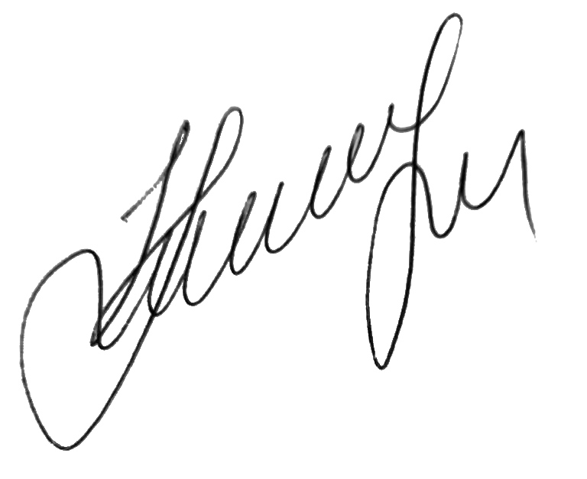………………………………………………………………………
by the DSL Maryna Jenkins
Date: 10.02.2023……………………………………………………

