Whistleblowing Policy
Policy Statement
Jenkins Enterprises is committed to the highest standards of the best practice in guardianship of international students. Concerns about poor practice within Jenkins Enterprises should usually be dealt with through the Jenkins Enterprises complaints procedure. However serious allegations may be raised by following the whistleblowing policy. It is the duty of all staff members of Jenkins Enterprises and those associated with Jenkins Enterprises, to raise any concerns so that improvements can be made. Raising concerns will not result in reprisals in any form.
This policy is intended to provide a means of making serious allegations about standards, conduct, financial irregularity or possible unlawful action in a way that will ensure confidentiality and protect those making such allegations in the reasonable belief that it is in the public interest to do so from being victimised, discriminated against or disadvantaged. This policy does not replace other policies and procedures such as the Jenkins Enterprises Complaints Procedure. This procedure applies to all Jenkins Enterprises employees and also includes associates, contractors, and schools. If an employee has a concern about the conduct of a fellow employee in the working environment (e.g. that they are not treating colleagues with respect) they should raise this with the Director Maryna Jenkins.
Policy
This procedure applies to, but is not limited to, allegations about any of the following:
- Conduct which is an offence or breach of the law;
- Alleged miscarriage of justice;
- Serious Health and Safety risks;
The unauthorised use of public funds;
- Possible fraud and corruption;
- Sexual, physical or verbal abuse, or bullying or intimidation of employees, customers or service users;
- Abuse of authority;
- Other unethical conduct.
Reporting
Jenkins Enterprises recognises that the decision to make an allegation can be a difficult one to make. However, whistleblowers who make serious allegations in the reasonable belief that it is in the public interest to do so have nothing to fear because they are doing their duty to those for whom a service is provided.
Jenkins Enterprises will take appropriate action to protect a whistleblower who makes a serious allegation in the reasonable belief that it is in the public interest to do so from any reprisals, harassment or victimisation.
Confidentiality
All allegations will be treated in confidence and every effort will be made not to reveal a whistleblower’s identity unless requested by the whistleblower. Jenkins Enterprises will not, without the whistleblower’s consent, disclose the identity of a whistleblower to anyone other than a person involved in the investigation/allegation. Sometimes the whistleblower might be asked to give a statement as part of the investigation, in which case their identity may have to be revealed.
Anonymous allegations
This policy encourages whistleblowers to put their name to an allegation wherever possible as anonymous allegations may often be difficult to substantiate/prove. Allegations made anonymously are much less powerful but anonymous allegations will be considered at the discretion of the Director Maryna Jenkins. In exercising discretion to accept an anonymous allegation the factors to be taken into account:
- The seriousness of the issue raised
- The credibility of the allegation; and
- Whether the allegation can realistically be investigated from factors or sources other than the complainant
Untrue allegations
No disciplinary or other action will be taken against a whistleblower who makes an allegation in the reasonable belief that it is in the public interest to do so even if the allegation is not substantiated by an investigation. However, disciplinary action may be taken against a whistleblower who makes an allegation without reasonable belief that it is in the public interest to do so (e.g. making an allegation frivolously, maliciously or for personal gain where there is no element of public interest).
Procedure for making an allegation
It is preferable for allegations to be made to, for example, an employee’s immediate manager to whom they report. However, this may depend on the seriousness and sensitivity of the issues involved and who is suspected of the malpractice. For example, if the whistleblower believes that management is involved it would be inappropriate to raise it directly with them. The whistleblower may then make an allegation direct to any of the following:
- The NSPCC whistleblowing helpline is 0800 028 0285 between 8am and 8pm Monday to Friday or email help@nspcc.org.uk
- Protect provide a free, confidential advice line for concerned staff to call before whistleblowing. The helpline is 020 3117 2520 and their website is: www.pcaw.co.uk.
- AEGIS Telephone number: 01453 821 293 or email yasemin@aegisuk.net
Allegation
Whether a written or oral report is made it is important that relevant information is provided including:
- The name of the person making the allegation and a contact point.
- The background and history of the allegation (giving relevant dates and names and positions of those who may be in a position to have contributed to the allegation);
- The specific reason for the allegation.
Although someone making an allegation will not be expected to prove the truth of any allegations, they will need to provide information to the person they have reported to, to establish that there are reasonable grounds for the allegation.
Action on receipt of an allegation
The line manager will record details of the allegation gathering as much information as possible, (within 5 working days of receipt of the allegation) including:
- The record of the allegation:
- The acknowledgement of the allegation;
- Any documents supplied by the whistleblower.
The investigator will ask the whistleblower for their preferred means of communication and contact details and use these for all communications with the whistleblower in order to preserve confidentiality.
If the allegation relates to fraud, potential fraud or other financial irregularity the Director Maryna Jenkins will be informed within 5 working days of receipt of the allegation. The Director Maryna Jenkins will determine whether the allegation should be investigated and the method of investigation.
If the allegation discloses evidence of a criminal offence it will immediately be reported to the Director Maryna Jenkins and a decision will be made as to whether to inform the Police or appropriate authorities.
Timetable
An acknowledgement of the allegation in writing within 10 working days with:
- An indication of how Jenkins Enterprises propose to deal with the matter;
- An estimate of how long it will take to provide a final response;
- An indication of whether any initial enquiries have been made;
- Information on whistleblower support mechanisms;
- Indication whether further investigations will take place and if not, why not.
Where the allegation has been made internally and anonymously, obviously Jenkins Enterprises will be unable to communicate what action has been taken.
Support
Jenkins Enterprises will take steps to minimise any difficulties which may be experienced as a result of making an allegation. For instance, if a whistleblower is required to give evidence in criminal or disciplinary proceedings Jenkins Enterprises will arrange for them to receive advice about the procedure and advise on the support mechanisms that are available.
Jenkins Enterprises accepts that whistleblowers need to be assured that the matter has been properly addressed. Thus, subject to legal constraints, we will inform those making allegations of the outcome of any investigation.
Responsibility for the procedure
The Director Maryna Jenkins has overall responsibility for the operation of this procedure and for determining the administrative processes to be followed and the format of the records to be kept.
Monitoring
A Register will record the following details:
- The name and status (e.g. employee) of the whistleblower
- The date on which the allegation was received
- The nature of the allegation
- Details of the person who received the allegation
- Whether the allegation is to be investigated and, if yes, by whom
- The outcome of the investigation
- Any other relevant details
The Register will be confidential and only available for inspection by the director.
Further it information and advice can be found here: https://www.gov.uk/whistleblowing
Contact details

Role | Name | Telephone Number/s | Email
The Director | Maryna Jenkins | +44 (0) 754 25 36 256 | infoukschools@gmail.com

Review
We are committed to reviewing our policy and good practice annually.
This policy was last reviewed on:
10.02.2023………………………………………(date)
Signed: …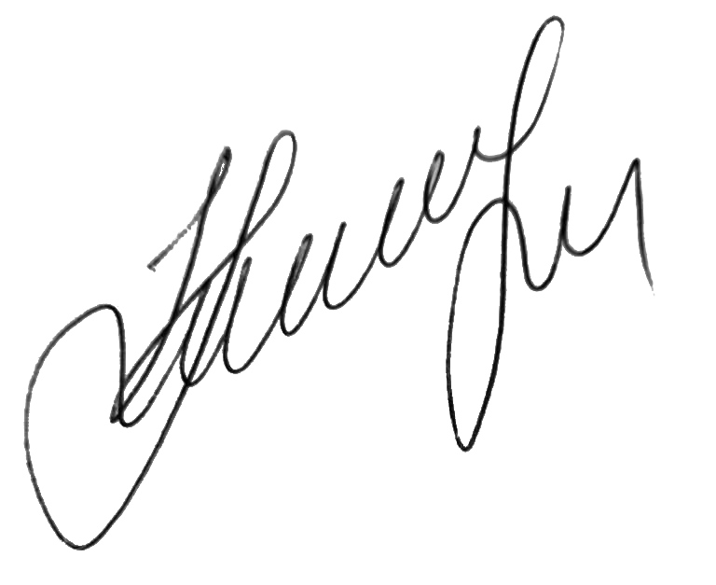………………………………………………………
by the DSL Maryna Jenkins
Date: 10.02.2023……………………………………………………

