Anti-Bullying (including Cyber-Bullying) Policy

Policy Statement
The purpose of this policy is:
- to help prevent bullying from happening to students in our care
- to make sure bullying is stopped as soon as possible if it does happen and that those involved receive the support they need
- to provide information to all staff, homestays, volunteers, students and their parents about what we should all do to prevent and deal with bullying.
Jenkins Enterprises believes that:
- children and young people should never experience abuse of any kind;
- we have a responsibility to promote the welfare of all children and young people, to keep them safe and to practice in a way that protects them.
Jenkins Enterprises recognises that:
- bullying causes real distress. It can affect a person’s health and development and, at the extreme, can cause significant harm;
- all children, regardless of age, disability, gender reassignment, race, religion or belief, sex or sexual orientation, have the right to equal protection from all types of harm or abuse;
- the potential impact of bullying on the wider family of those affected so will work in partnership with parents/carers regarding all reported bullying concerns and will seek to keep them informed at all stages
- everyone has a role to play in preventing all forms of bullying (including online) and putting a stop to it.

Jenkins Enterprises undertakes:
- to monitor and review our anti-bullying policy and practice on a regular basis
- to support staff to promote positive relationships to help prevent bullying
- to ensure students in our care are aware that bullying concerns will be dealt with sensitively and effectively; that everyone should feel safe to learn and abide by the anti-bullying policy
- to utilise support from the Local Authority and other relevant organisations when appropriate.

Contact Details
Designated lead for safeguarding and child protection
Name: Maryna Jenkins
- Phone: +44 (0) 754 25 36 256
- e-mail: infoukschools@gmail.com

NSPCC Helpline: 0808 800 5000

Bullying is repeated over time behaviour that hurts a student or group physically or emotionally and is often motivated by prejudice against particular groups, for example, on grounds of race, religion, culture, sex, gender, homophobia, special educational needs and disability, or because a child is adopted or is a carer.
Bullying includes a range of abusive behaviour that is:
• repeated;
• intended to hurt someone either physically or emotionally.
It may occur directly or through cyber-technology (social websites, mobile phones, text messages, photographs and email).

Cyberbullying is bullying that takes place using technology including social media sites, mobile phones, gaming sites. Unlike bullying in the real world, online bullying can follow the child wherever they go, via social networks, gaming and mobile phones.

Online abuse is a type of abuse that happens on the web, whether through social networks, playing online games or using mobile phones and can include: grooming (building an emotional connection with a child to gain their trust for the purposes of sexual abuse, sexual exploitation or trafficking), sexual abuse, ‘sexting’ or youth produced imagery, sexual exploitation, county lines gang recruitment, radicalisation or emotional abuse from people they know as well as from strangers.

Jenkins Enterprises recognises that Bullying and Cyberbullying can take different forms and no single sign will indicate for certain that a child is being bullied, to do our best to indicate any forms of bullying, and protect from it students in our care we follow recommendations given by NSPCC.
https://www.nspcc.org.uk/what-is-child-abuse/types-of-abuse/bullying-and-cyberbullying/

Homestays play a crucial role in ensuring that the students who stay with them use the internet and mobile devices in accordance with the guidance contained within the Homestay Manual and The Staff/ Homestay Code of Conduct. Maryna Jenkins will take every opportunity to help homestays understand the issues by providing them regular safeguarding updates and training to an appropriate basic awareness level.

Students are responsible for using the internet and mobile devices in accordance with the guidance in the Student Handbook. Maryna Jenkins further supports students in raising their awareness of how to stay safe online through our social media updates, policies and website.

To supervise internet access and set boundaries about what staff, students and homestays can and cannot do online we encourage them to set an appropriate agreement with students according which we would ask the homestay to restrict internet access for an agreed period of time if a child doesn’t comply with the rules.

Below is some suggested advice for talking to children about online safety:
https://www.thinkuknow.co.uk/parents/articles/having-a-conversation-with-your-child/
https://www.nspcc.org.uk/preventing-abuse/keeping-children-safe/online-safety/talking-your-child-staying-safe-online/
Homestays are asked to use privacy settings, parental controls and built in internet safety features provided by the major internet service providers.
The UK Safer Internet Centre has guides for parental controls (homestays).
https://www.saferinternet.org.uk/advice-centre/parents-and-carers/parental-controls-offered-your-home-internet-provider

Jenkins Enterprises asks homestays to be doing all that they can to limit children’s exposure to the above risks from the IT systems at the home. As part of this process, homestays should ensure appropriate filters and monitoring systems are in place. Whilst considering their responsibility to safeguard and promote the welfare of children, homestays should consider the age range of their pupils, the number of pupils, and how often they access the IT system.

The NSPCC website ‘Online Safety’ outlines controls that homestays can implement to filter and monitor what a child in their house can see.
https://www.nspcc.org.uk/preventing-abuse/keeping-children-safe/online-safety/

The NSPCC provide advice for homestays on parental controls which allow a number of different things to happen including filtering and blocking content, setting different profiles so that each family member can access age appropriate content and restricting information that can be shared:
https://www.nspcc.org.uk/preventing-abuse/keeping-children-safe/online-safety/parental-controls/

The NSPCC advice for tracking children’s online activity via devices includes location tracking, taking and sending pictures, setting up parental controls, public Wi-Fi and parent protection apps.
Full details can be found on the website:
https://www.nspcc.org.uk/preventing-abuse/keeping-children-safe/online-safety/

The NSPCC encourage talking to children about social networks using ‘Net Aware’ to stay up to date with the social network sites and what you need to know about for example reporting and privacy settings:
https://www.net-aware.org.uk/

The NSPCC encourage talking to children about online privacy and being ‘Share Aware’:
https://www.nspcc.org.uk/preventing-abuse/keeping-children-safe/share-aware/

Child Exploitation & Online Protection Centre – internet safety (CEOP) Thinkuknow: https://www.thinkuknow.co.uk/

UK Safer Internet Centre: https://www.saferinternet.org.uk/

Internet matters – helping parents and caregivers keep children safe online: https://www.internetmatters.org/

How social media is used to encourage travel to Syria and Iraq: A briefing note: https://www.gov.uk/government/publications/the-use-of-social-media-for-online-radicalisation

For homestays experiencing any internet safety issues with children the NSPCC have set up a helpline: 0808 800 5002.

Procedures
We will take seriously and investigate any bullying or cyber-bullying concerns that are reported to us:
- Students will be made aware that they can talk to their parents, teachers, homestay, or a member of Jenkins Enterprises staff about any bullying concerns they may have;
- Jenkins Enterprise’s staff member may receive a report of any suspected abuse from a student, parent or other source by face to face disclosure, email or telephone call. This disclosure will be recorded in writing by the member of staff (using the ‘Tell Explain Describe’ model if the information is being given by a student);
- Any concerns raised by a student, parent, homestay, member of staff or other source will be reported within 24 hours to Maryna Jenkins (DLS). The written record (see above) must be submitted at this time;
- The DSL will hold an emergency strategy meeting to discuss the incident, assess the alleged threat and risk to the student (including any relevant facts about the child which may affect their vulnerability including age and ability), implement an action plan and continue to review the situation until a resolution has been achieved. Written notes will be kept securely of this meeting by the DSL;
- The DSL will arrange for the young person to be helped and supported in recognition of the pressures (and possible vulnerabilities) they may have been under as a result of the suspected abuse;
- Any concerns that bullying (including cyber-bullying) has taken place at a student’s school will be referred to the DSL of the school concerned;
- If the alleged bullying incident involves a member of the homestay family, or another student staying at the homestay, Jenkins Enterprises will investigate fully as outlined above and if necessary find alternative accommodation for the student;
- Parents will be kept informed about the situation and the actions that the members of Jenkins Enterprises are taking unless there is good reason to believe that involving these parties would put the young person at risk of harm;
- We will support the victim and the perpetrator (if they are a student in our care) and monitor students well-being following a bullying incident for as long as necessary;
- Where there is ‘reasonable cause to suspect that a child is suffering, or likely to suffer, significant harm’ due to bullying, we will refer the matter to local agencies;
- Please note that strong sanctions such as termination of our contract may be necessary in cases of severe and persistent bullying;
- Full records will be kept of any bullying concerns and of any actions taken. These will be held confidentially by Maryna Jenkins
- Whilst it is acknowledged that bullying may be repeated over time, we will take action in response to a single incident and make an appropriate record.

Specific cyber-bullying procedures in addition to the above
- In the case of cyber-bullying support for the student could include helping them to understand how to recognise the early signs of online abuse, the wider issues and motivations of online abuse and making available relevant information and material. This help and support could be provided by accredited organisations such as the school, National Society for the Prevention of Cruelty to Children (NSPCC), ChildLine and National Crime Agency (NCA) – Child Exploitation and Online Protection Centre (CEOP) websites and helplines;
- The DSL will ensure that viewing of the images or other content is only made where there are good and clear reasons to do so (unless unavoidable because the student has willingly shown a member of staff), basing incident decisions on what the DSL has been told about the content of the imagery or other content. The DSL will ensure that staff members do not search through devices and delete imagery unless there is a good and clear reason to do so;
- The DSL will consider the need to ask for the student to produce the device as evidence. The viewing of any images, other content or seizing of any devices will be recorded including those present, date and time;
- The incident will be referred to a statutory agency (Children’s Services on the Local Authority telephone number or the police by dialling 101) immediately if there is a concern a young person has been harmed or is at immediate risk of harm (telephone the police by dialling 999). This would include information coming to light if at the initial stage:
  - The incident involves an adult;
  - There is reason to believe that a young person has been coerced, blackmailed or groomed, or if there are concerns about their capacity to consent (for example owing to special educational needs);
  - What you know about the imagery or other content suggests the content depicts sexual acts which are unusual for the young person’s developmental stage, or are violent;
  - The imagery or other content involves sexual acts and any pupil in the imagery is under 13;
  - You have reason to believe a student is at immediate risk of harm owing to the sharing of the imagery, for example, the young person is presenting as suicidal or self-harming;
  - Where the material or activities found or suspected are illegal and there is no immediate risk to the child, The Child and Exploitation Online Paedophile Unit should be informed;
  - If none of the above apply, the DSL may decide to respond to the incident without involving the police or children’s social care. The DSL can choose to escalate the incident at any time if further information/concerns come to light. The decision should be recorded in line with the Safeguarding Policy and Child Protection Policy, and regularly reviewed throughout the process of responding to the incident;
  - The decision to respond to the incident without involving the police or children’s social care would be made in cases when the DSL is confident that they have enough information to assess the risks to pupils involved, and the risks can be managed within Jenkins Enterprises support framework and network for the child.
- The DSL will advise to the young person to delete imagery or other content, and to confirm they have deleted the imagery. Young people should be given a deadline for deletion across all devices, online storage or social media sites on the basis that possession of youth produced sexual imagery is illegal. Where a young person refuses or is later discovered to have not deleted the images or other content, they are committing a criminal offence and the police may become involved. A record will be made of these decisions as per the Safeguarding Policy including decisions, times, dates and reasons. Jenkins Enterprises may wish to invoke their own measures to discourage young people sharing, creating or receiving images in line with behaviour policies;
- Where the DSL is aware that youth produced sexual imagery or other content has been unavoidably viewed by a member of staff, the DSL should ensure that the staff member has appropriate support. Viewing youth produced sexual imagery or other content can be distressing for both young people and adults and appropriate emotional support may be required;

- Where police action has been instigated for an incident involving a member of staff or volunteer, Jenkins Enterprises internal procedures will take place at the conclusion of the police action. A suspension will be likely to take place before the internal procedures begin.
Related policies and procedures

This policy statement should be read alongside our organisational policies and procedures including:
- Child protection/safeguarding policy
- Code of conduct for staff and volunteers
- Student behaviour code of conduct

Review
We are committed to reviewing our policy and good practice annually.
This policy was last reviewed on: 10.02.2023………………………………………………………(date)
Signed: …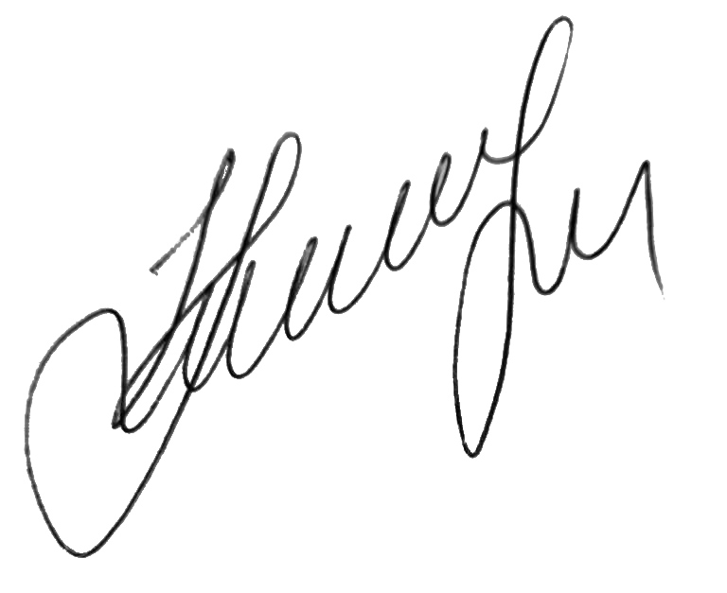………………………………………………………………………
by the DSL Maryna Jenkins
Date: 10.02.2023……………………………………………………………

