Welfare, Health and Safety Policy

Statement
Jenkins Enterprises places the highest priority on ensuring the health and safety of the students in their care. On top of our stringent recruitment procedures, outlined in our safer recruitment policy, we make thorough checks on the accommodation provided by our homestays.
The member of staff responsible for any welfare, health and safety issues is Maryna Jenkins phone: +44 (0) 754 25 36 256.

Procedure
Jenkins Enterprises will conduct an initial assessment visit in person to each homestay before placing any students within the household. During this visit, suitable health and safety checks will be conducted and a simple risk assessment of the property undertaken along with a check on the suitability of the accommodation. Comprehensive notes of this visit will be recorded within the homestay file.
The minimum health and safety checks will be undertaken. These are in line with the AEGIS requirements:
- Check that the home has a minimum of one smoke alarm to be installed on every storey.
- Check that a carbon monoxide alarm is installed in any room containing a gas, liquid or solid fuel burning appliance.
- Check that an annual landlord gas safety has been undertaken by a Gas Safe registered engineer (a copy of the certificate must be provided to the guardianship organisation.)
- The guardianship organisation will check that the homestay has ensured that the electrical system is safe, e.g. sockets and light fittings are secure and not overloaded and any appliances used by the student are safe.
- The guardianship organisation must check that the homestay discusses the possible evacuation routes from the property with students on a regular basis. If doors or windows are locked students must know where to find the key in the event of a fire.
- If fire extinguishers and fire blankets are provided the guardianship organisation will check that these have been suitably serviced.
- Where open fires are used, a check will be made that suitable fire guards are in place when the fire is lit.
- The guardianship organisation will check that any matches / lighters should be appropriately stored.
- The guardianship organisation will check that a basic first aid kit is available. This should include, plasters, sterile eye-pad, triangular bandage, safety pins, non-medicated wound dressing, disposable gloves, leaflet giving guidance on first aid.
- The guardianship organisation will check that any prescription medication and drugs should be kept safely especially when hosting young students.
- The guardianship organisation will check that alcohol should be appropriately stored.
- The homestay should have an awareness of basic food hygiene when preparing meals for students.
- Advisory: We advise students to use UK plugs only and not to use overseas adaptors as these can be a source of fire. UK mobile phone and laptop adaptors are relatively easy and inexpensive to obtain in most cases.
The guardianship organisation will conduct at least an annual visit in person to each homestay held on their records. During this visit, support will be offered to the homestay and suitable checks for safety and suitability will be undertaken to ensure any changes since the last visit are properly recorded and felt to be acceptable. The smoke alarms and carbon monoxide alarms should also be tested. Comprehensive notes of this visit must be recorded within the homestay file.

Any issues in relation to the welfare health and safety of students should be reported immediately to: the DSL Maryna Jenkins via email: infoukschools@gmail.com or telephone +44 (0) 754 25 36 256. A full investigation will take place, and action taken where necessary. A full record of the concern and action taken as a result will be maintained in the Jenkins Enterprises Health and Safety file.

Review
We are committed to reviewing our policy and good practice annually.
This policy was last reviewed on: 10.02.2023……………………………………………………(date)
Signed: 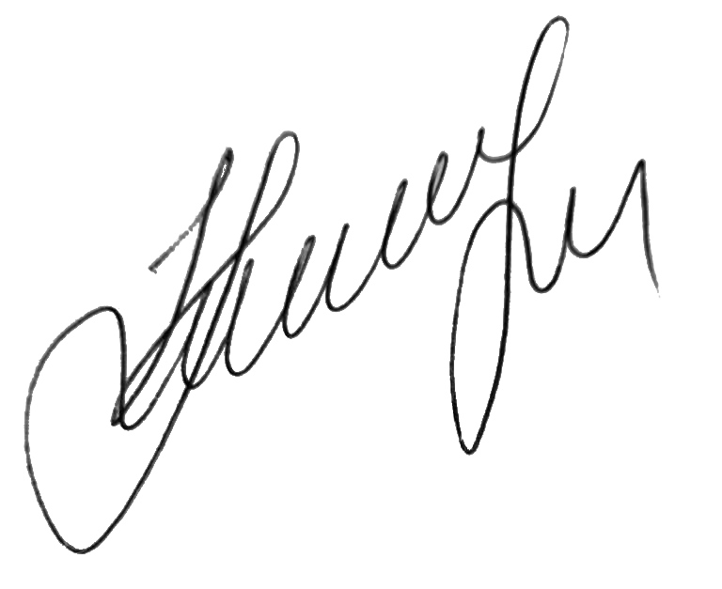…………………………………………………………………………
by the DSL Maryna Jenkins
Date: 10.02.2023…………………………………………………………

