Staff and Homestay Code of Conduct

The following code of conduct for staff and homestays gives clear guidance on behaviour that Jenkins Enterprises expects from all members of staff and homestays working within the organisation. These guidelines confirm and reinforce the professional responsibilities of all staff and homestays. They help adults establish safe practices and reduce the risk of false accusations or improper conduct.

Code of Conduct
Power and positions of trust
In your role as a member of staff or homestay, you will have power over students and will hold a position of trust. It is imperative that these are not abused in any way. Jenkins Enterprises staff and homestays should be aware of their own conduct and ensure that their professional practice is clear and unambiguous. Staff should ensure that they work in an open and transparent way, not showing favouritism and by treating students respectfully and fairly irrespective of culture, disability, gender, language, racial origin, religious belief and sexual orientation.
Duty of care to children and young people
All staff, volunteers and homestays have a duty of care to children and young people. As such they must adhere to the various policies, including the safeguarding and child protection policy that outline how we safeguard students in our care.
Exercising professional judgement
Jenkins Enterprises recognises that this guidance may not cover every eventuality. There may be times when staff use their professional judgement to deal with situations not outlined in this section. In such circumstances staff should always advise their senior colleagues of the justification for any action taken or proposed.
Use of appropriate language
It is important to remember that whilst undertaking your role, you are representing Jenkins Enterprises . We expect all staff and homestays to be polite and courteous whilst undertaking their duties. It is inappropriate to swear or use abusive language.
Sexual contact with young people
Any (contact or non-contact activity) sexual behaviour (including grooming of a child so sexual abuse can take place), by a member of staff or homestay with or towards a student is unacceptable and could be a matter for criminal and/or disciplinary proceedings. Students are protected by the same laws as adults in relation to non-consensual sexual behaviour, and by additional legal provisions depending on their age and understanding.
Communication with Students
Communication with students should only be in a professional capacity, using appropriate language and tone. Most communication goes through phone or WhatsApp.
Social contact with Students
Staff members should not give their personal contact details to students for example email address, home or mobile telephone numbers or details of web based identities. If students locate these by any other means and attempt to contact or correspond with the staff member, they (staff member) should not respond and must report the matter to their line manager. Students and staff should communicate for professional reasons using the company email addresses and telephone numbers. It is inappropriate for staff or homestays to befriend students and mix with them socially as a friend.
Social contact with Parents / Agents / staff at partner schools
As for students, it is inappropriate for guardianship organisation staff or homestays to befriend parents, agents or school staff on social media (unless they were previously friends). Jenkins Enterprises expects any contact that staff or homestays have with parents, agents and staff at partner schools to be courteous and polite as the individual is representing the organisation. It is inappropriate for staff or homestays to befriend parents, agents or staff at partner schools and mix with them socially as a friend unless of course they were previously friends before working with them.
Physical contact including restraint
Guardianship organization staff or homestay family members are advised to avoid physical contact with students as even when well intentioned, this contact may be misconstrued by the student, an observer or any person to whom this action is described. There may also be cultural, gender sensitive or religious reasons about touching which the homestay member is not aware of. Guardianship organization staff and homestay family members must be aware that any physical contact with a student may need to be explained and would be open to scrutiny. Physical restraint should only be used if the student is placing themselves or others at risk. Any restraint must be reported immediately to Jenkins Enterprises . A written record must be submitted. Parents will be made aware and Jenkins Enterprises will investigate fully.
An outright ban on any corporal punishment
It is illegal to use corporal (physical) punishment. Any reported incidences of corporal punishment will be reported by Jenkins Enterprises to the police.
Care of distressed Students
Where a student is upset or distressed (for example due to homesickness) remember that sympathy and help can be given using kind words. Also, sitting with the student and listening to them until they feel better can also be of great comfort. Staff and homestays should, therefore, use their professional judgment at all times and in cases where this may be unavoidable (for example a young child who has fallen over, makes physical contact with the primary carer first or is crying with homesickness), we would recommend asking a child if physical comfort is wanted before giving it. However in the majority of cases it would not be appropriate and we do not recommend physical contact, and would encourage comforting the child as detailed above.
One-to-one meetings
Members of staff and homestays should be mindful when meeting students on a one-to-one basis. Staff meeting students should do so in a public space, such as a school classroom, meeting room or common room. If meeting students outside of school the meetings should take place in a public area such as a coffee shop. In the homestay environment, homestays and their families should avoid going into the student’s bedroom or inviting them into their bedroom.
Students’ entitlement to privacy
Guardianship organization staff and homestays must respect student’s right to privacy. That means not entering their bedrooms (unless the homestay is required to clean the room, and this should only be undertaken with prior warning and when the student is not in the room), ensuring that bathrooms have suitable locks and respecting the student’s right to retreat to their rooms or a quiet area in the home if they feel the need. When students wish to email or call home, they should be allowed to do so in privacy.
Transporting Students
Staff may at times be expected to transport students, for example to the airport, homestay, school or other out of school activities. A log of these journeys should be recorded. Any cars used must meet all legal requirements (e.g. MOT and insurance). Students should travel in the back of the vehicle and must wear seatbelts. Booster seats should be used where required. Homestays transporting students should do so in line with the guidance included in the Homestay Handbook.
Gifts and rewards
Jenkins Enterprises staff should not give gifts to students on a regular basis and should not give gifts of any significant value. Similarly, such gifts should not be given to the families of students as this could be interpreted as a gesture to groom or bribe a student. Where a reward is given to a student, this should be in accordance with agreed practice, consistent with the behaviour policy and not based on favouritism. On no account should any monetary gifts be given.

There may be occasions where students or their families may want to present you with a gift, for example as a thank you. You can accept gifts (not monetary) and hospitality, which are small gestures and are of low value. Any gift or hospitality which is more than just a token, defined as having a large value should be politely refused or returned.
Use of photographs and videos
Staff should ensure that only photography, videos or images of students are taken with their and their parent’s consent and that these are published where such consent has been obtained. Images should be securely stored and used only by those authorised to do so. Under no circumstances should staff take images of students without consent or without the students knowing that the images are being taken. Staff should always be able to justify images of students in their possession and avoid making images in one to one situations.

Searching Students and their belongings
It may be necessary in certain circumstances to search students and belongings. This may be due to suspected possession of a prohibited item. This includes:
  - knives or weapons;
  - alcohol;
  - illegal drugs;
  - stolen items;
  - tobacco and cigarette papers;
  - fireworks;
  - pornographic images;
  - any article that a member of staff or homestay reasonably suspects has been, or is likely to be, used to commit an offence or injure a person or damage property.
Consent should be sought by the student, although a search may still be conducted if consent is not received. It is important that such a search is handled sensitively. Homestays should contact the DSL Maryna Jenkins Phone: +44 (0) 754 25 36 2569 who will attend the house to undertake the search, unless it is felt that a delay may put individuals at risk. The search should be conducted by a member of the Jenkins Enterprises staff of the same gender as the student. The search should be conducted with the room door open and with a witness and the student present. If a search is conducted on students, please be aware that only outer clothing (not worn next to the skin or immediately over a garment being worn as underwear) may be removed. Staff cannot carry out an intimate search; this can only be carried out by the police. A full incident report must be completed and parents informed.
Whistleblowing
The Jenkins Enterprises Whistle Blowing Policy provides guidance to staff on how to deal with malpractice in the workplace where there is concern for the safety of children.
Review
We are committed to reviewing our policy and good practice annually.
This policy was last reviewed on: 10.02.2023………………………………………………………(date)
Signed: …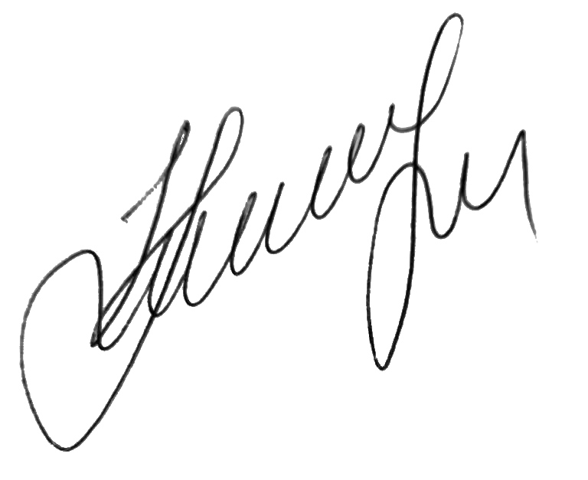………………………………………………………………………
by the DSL Maryna Jenkins
Date: 10.02.2023…………………………………………………………

