Student Behaviour Code of Conduct

Statement

This Student Behaviour Code of Conduct outlines the positive behaviour it expects from students. It also provides information about specific laws in the UK. The aim is to provide guidance in key areas of Jenkins Enterprises expectations. The guidance is written for the benefit of students, parents /agents, staff and homestays.

Behaviour Code of Conduct
Behaviour and conduct when staying with a Homestay
Jenkins Enterprises expects all of their students to be polite and courteous when staying with a homestay. In the UK, it is expected that you say “please” and “thank you” when asking for and receiving items. Your homestay is not a hotel and the expectation is that you will be included as part of the family. As such, you will be expected to engage with family members, joining them at mealtimes, and possibly helping with chores such as laying the table. Your homestay will explain their own house rules with you when you arrive. Please do ask them if you have any questions.

Curfew arrangements
Students who have permission to go out on their own will be required to return to homestays by the following times:

- 15 and under: Must be accompanied by an adult member of host family
- 16 and 17: Must be home by 10pm at the latest
- 18 and over: Must be home by 11pm at the latest

Jenkins Enterprises`suggests that student bedtimes should be as follows:
- 12 and under 9pm
- 13 – 15 10 pm
- 16 – 17 10:30pm
- 18 and over 11pm

Any deviation to these times should be discussed with the homestay.

All students who are permitted to go out unaccompanied by their homestay must take their mobile phone (fully charged) with them and keep this switched on. It is important that if students do go out unaccompanied, that they let the homestay know where they are going and roughly know how long they will be out. If for any reason they are delayed, students must contact the homestay to inform them.
If students have weeknight activities or work commitments, later weeknight home times can be negotiated, however it is expected that homestay students will usually eat dinner with their homestay families, and focus on their studies in the evenings.
Students should be reminded of the following for their own safety:
• It is advisable not to carry too much cash.
• It is best to travel in a group whenever possible.
• Avoid catching public transport late at night (i.e. after 8pm).
• Avoid “unsafe” areas at night.

Use of the kitchen area
Most homestays will prepare meals for you (breakfast, lunch and dinner). You may want to help the family in their meal preparations or cook something yourself. Please do talk to your homestay about this and they will advise you how to use the kitchen and the necessary safety rules. If you use any kitchen equipment or surfaces, you should leave the kitchen area in a tidy manner. If you have own food that you wish to eat during your stay, please let your homestay know so that this can be stored safely (for instance in a fridge if required). You will be able to access drinks and snacks throughout the day, such as fruit or biscuits. Your homestay will explain how you can access these.

Use of the bathroom
Students are asked to be respectful of the family routines. If you are sharing a bathroom, please be considerate with the time taken to shower and bathe as others may need to use the facility. You also should ensure that shower curtains are placed on the inside of the shower cubicle/bath to prevent bathroom flooding. Please leave the bathrooms tidy. Some families may have limits on the amount of hot water available each day due to their boiler capacity. Please discuss the best times for showering or taking a bath. It is not usually necessary to shower or bathe more than once a day. For female students, Homestay Hosts must provide a bin for sanitary disposal, or indicate an alternative method for sanitary disposal. Please ensure that you lock the door of the bathroom when in use and ensure that you are suitably clothed when travelling to and from the bathroom.

Use of the Wi-Fi / access to the home computer
Please discuss Wi-Fi access with your homestay. Some families have packages where they have a limit on the data they may use in a month; therefore streaming films for example would be inappropriate. Please note that homestays may have filters on their internet and may use parental controls to prevent access to inappropriate sites. Some homestays may turn off the Wi-Fi at bedtime. Students should use their own devices rather than the family’s home computer.

Laws regarding the consumption of alcohol
Jenkins Enterprises does not permit their students to consume alcohol whilst under their care, including when they are staying at a homestay. In the UK it is illegal for people under 18 to buy alcohol in a pub, off-license, shop or elsewhere. In most cases, it is against the law for anyone to buy alcohol for someone under 18 to drink in a pub or a public place.

Laws regarding the use of drugs and illegal substances
Jenkins Enterprises prohibits students from using recreational drugs and illegal substances whilst in their care. In the UK you can get a fine or prison sentence if you:
- take drugs
- carry drugs
- make drugs
- sell, deal or share drugs (also called ‘supplying’ them)
If you are under 18, the police are allowed to tell your parent, guardian or carer that you’ve been caught with drugs.

Laws regarding smoking
Jenkins Enterprises prohibits students from smoking whilst in their care. In the UK, it is illegal to buy cigarettes if you are under the age of 18.

Laws regarding sexual activity
Jenkins Enterprises prohibits students from engaging in sexual activity whilst in their care, even if they are over the age of consent. In the UK the age of consent is 16. That means that it is illegal to have sex with someone under the age of 16.

Laws regarding tattoos and body piercings
Jenkins Enterprises prohibits students from having a tattoo or body piercing whilst in their care. In the UK, it is illegal to tattoo a young person under the age of 18, even if they have parental consent. There is no legal age of consent for body piercing, and so it is legal for someone under the age of 18 to have a piercing as long as they have consented to it. Children under the age of 16 cannot legally consent to a genital (or in the case of girls, nipple) piercing, as it's considered to be indecent assault.

Arrangements when Students wish to stay away from the homestay.
While staying with your homestay you are not allowed to stay away from the homestay unless permission has been given by Jenkins Enterprises.

Bullying & Cyberbullying.

Bullying is a range of unacceptable behaviours that hurt, intimidate, frighten, harm, humiliate, undermine or exclude an individual or group. Jenkins Enterprises do not condone any form of bullying.

Review
We are committed to reviewing our policy and good practice annually.
This policy was last reviewed on: 10.02.2023………………………………………………………(date)
Signed: 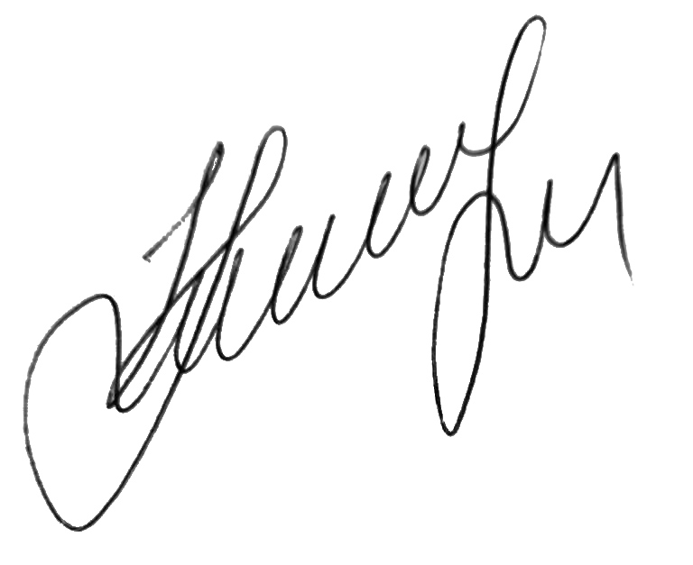…………………………………………………………………………
by the DSL Maryna Jenkins
Date: 10.02.2023…………………………………………………………

